Extension Installation:

Go To Settings, then extensions:



Turn On Developer Mode



Load Unpacked and Select EyeCanNew



Select Folder

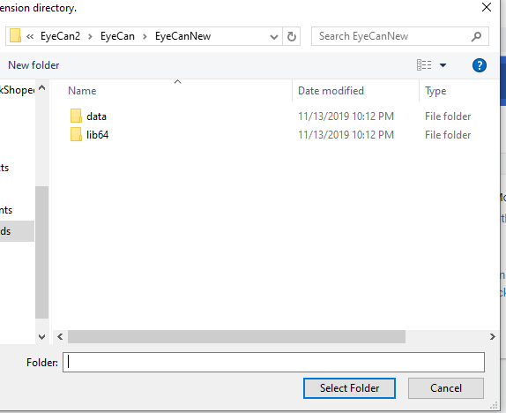

Restart Chrome and you can now see The EYECAN extension

Choose mouse.

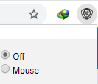

Navigate to localhost/eyesite/newhomepage.php

See The Video Attached.